The California Farm Labor Contractor Association is proud to support the growth and development of the next generation by providing college and trade school scholarships for students who are farmworker employees (or their children) of California farm labor contractors.
CFLCA, with the help of our generous sponsors and donors, will award scholarships in the amount of $1,000 to $10,000 for up to 18 students. An online version of the application is available at calflca.org/Scholarships.
Please read the following requirements to determine if you may qualify for a scholarship this year! If you do, please follow the application directions, and attach all necessary documentation requested below to be considered as a scholarship recipient.
We look forward to the opportunity to support you on your path through higher education.
La Asociación de Contratistas de Labor Agrícola de California se enorgullece de apoyar el crecimiento y desarrollo de la próxima generación al proporcionar becas universitarias y de escuelas de oficios para estudiantes que son empleados agrícolas (o sus hijos) de contratistas de labor agrícola de California.
CFLCA, con la ayuda de nuestros generosos patrocinadores y donantes, otorgará becas por un monto de $1,000 a $10,000 para hasta 18 estudiantes. La versión en línea de la solicitud está disponible en CalFLCA.org/Scholarships. Lea los requisitos a continuación para determinar si podría calificar para recibir una beca este año. Si califica, siga las instrucciones de la aplicación y adjunte toda la documentación necesaria como se solicita a continuación para ser considerado como beneficiario de una beca.
Esperamos tener la oportunidad de apoyarlo en su camino hacia la educación superior.
Coordinated By:
California Farm Labor Contractor Association
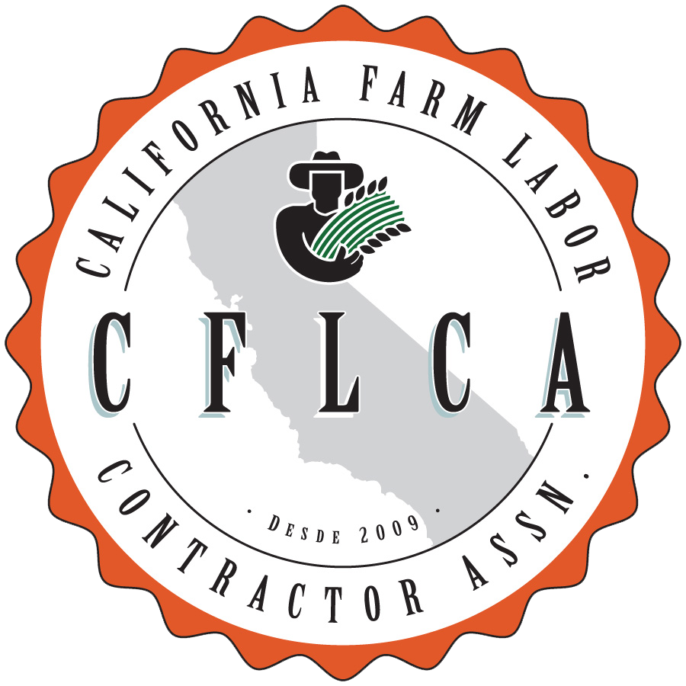
Gabriel Gomez-Sandoval Memorial Farmworker Scholarship

 | CALIFORNIA FARM LABOR CONTRACTOR ASSOCIATION  2023 SCHOLARSHIP APPLICATION  Due: The application MUST be postmarked on or before June 30, 2023 | 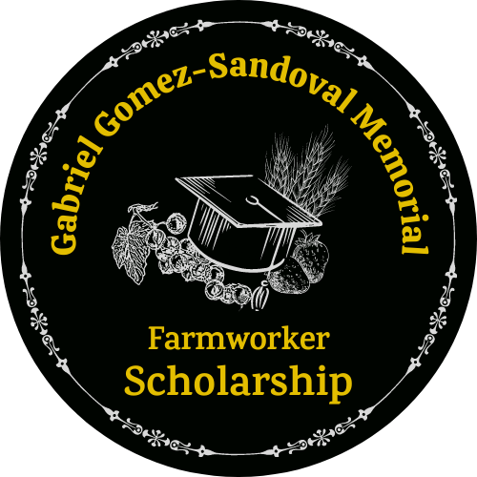
The California Farm Labor Contractor Association (CFLCA) has established a scholarship fund to benefit farmworkers, and the children of farmworkers who plan to pursue higher education. CFLCA, with the help of our generous sponsors and donors, will award scholarships in the amount of $1,000 to $10,000 for up to 18 students. Online version of application is available at calflca.org/Scholarships.
Eligibility Requirements
The minimum eligibility requirements for all scholarships are as follows:
- Applicants must be farmworkers or children of farmworkers who have been employed by a California Farm Labor Contractor (FLC) in the past 12 months.
- Applicant must be accepted to and/or enrolled in an accredited postsecondary education institution (college, university, or vocational school).
- Applicant must have a cumulative GPA of 2.5 and above.
- Children of grower/packer employees, FLC, management/administrative staff, are ineligible.
- Applications are weighed higher for the children of CFLCA FLC member employees. *
- Applications are weighted higher for the students who plan to pursue a major in agriculture or a supporting field. *
How to Apply
Applicants must complete the CFLCA Scholarship Application Form. All requested information must accompany applications. ** Missing documentation or a specific area not completed on the application will result in the application not being considered when choosing award winners.
Please submit the following in one package:
(Use the following as a checklist to ensure all below items are complete and attached in order to be considered)
- Application form with signature(s).
- A 300 to 400 word typed essay on why you should be selected to receive this scholarship.
- A one-page typed resume of your work, community service, awards, educational and extra-curricular
- activities.
- One letter of recommendation (from a teacher, employer, or volunteer organization)
- Most recent official school or college transcript (copies are acceptable).
- Proof of college acceptance letter (at any accredited postsecondary educational institute) or current student enrollment.
- Copy of check stub verifying applicant or family member has worked for a FLC in the past 12 months.
Send Applications
California Farm Labor Contractor Association
Attn: Scholarship Committee
1809 S Street, #101-246
Sacramento, CA 95811
or
E-mail: info@calflca.org (E-mailed applications must be in PDF format with all supporting documents (listed above) included to be considered for a scholarship)
__________________________________________________________________________________
*Final decisions are made by the Gabriel Gomez-Sandoval Memorial Farmworker Scholarship Committee.
**All information is subject to further verification by the Gabriel Gomez-Sandoval Memorial Farmworker Scholarship Committee. Including but not limited to: contacting your reference, your current school, or the postsecondary education institution.
CALIFORNIA FARM LABOR CONTRACTOR ASSOCIATION
2023 SCHOLARSHIP APPLICATION FORM
Please provide the following information for the 2023 Fall term.
Application package must be postmarked on or before June 30, 2023
PLEASE PRINT OR TYPE
Applicant Information
Name: First____________________Middle__________________Last________________________
Mailing Address: __________________________________________________________________
City: _______________________________ State: ______________ Zip: _____________________
Phone: _______________________________ E-mail:___________________________________
Farm Labor Contractor (FLC) Affiliation- Where You or a Family Member Worked
FLC Name: _________________________________________________ CFLCA Member? Yes No
Name of family member who worked for FLC:
Relation to applicant: _______________________________________________________________
College/University Information
College Name: ____________________________________________________________________
Address: ________________________________________________________________________
City: _______________________________ State: _____________ Zip: ______________________
Major: ________________________________ Minor (optional): ____________________________
Expected Degree: ____________________________ Expected Graduation Year: ______________
High School Attended: __________________________________ Graduation Year: _____________
Cumulative High School GPA (based on a 4.0 scale): _____________________________________
Cumulative College GPA (if in college): ________________________________________________

I hereby certify that all information provided in this application is true and correct. I further agree that if I withdraw from school or transfer schools during the term of this scholarship (if granted), that the unused balance is forfeitable to the CFLCA Scholarship Program, and I shall notify the CFLCA within 30 days.
I hereby understand that if chosen as a scholarship recipient, I must provide evidence of enrollment/registration at the post-secondary institution of my choice, a photograph, and a short bio before scholarship funds can be awarded.
I also give CFLCA permission to publish my name, photograph, resume and essay in any media and public relations materials, press release, or publication produced or distributed by CFLCA if I receive a CFLCA Scholarship Award.
Applicant’s Signature: ____________________________________ Date: _____________________

Parent or Guardian Signature: ______________________________ Date: _____________________
Parent or legal guardian signature is required if the applicant is under 18 years of age at the time of application.

